Конкурсна робота
Кращий урок/позакласний захід/ з Пізнайко
Ігрова діяльність в позакласній роботі
AFTER-CLASS ACTIVITY FOR PUPILS OF THE SECOND-FORTH FORMS
SUBJECT: AT THE PARTY WITH POSNAYKO: POSNAYKO MEETS NEW FRIENDS.
Objectives: to summarize the vocabulary on the topics ‘Numbers’, ‘Days of the week’, ‘At the party’, ‘Hobbies’, ‘Household duties’; to develop understanding, using active vocabulary; to teach pupils to work in groups and pairs; to develop speaking skills; to develop creative thinking; to motivate learners to free speaking and learning English.
Materials: a tape-recorder, tracks: - ‘Football team’// Posnayko kids magazine № 1, 2010.
- ‘My hobby song’// Posnayko kids magazine № 11, 2010.
- ‘Hello song’// Posnayko kids magazine № 9, 2010.
- ‘Days of the week’// Posnayko kids magazine № 3, 2010.
- ‘Let’s rock’n’roll’// Posnayko kids magazine № 2, 2010.

Procedure
Teacher: Good afternoon, boys and girls! I’m glad to see you. How are you? I am so glad to be with all of you, and you? Today we are going to have a party together with our friend. Meet Posnayko. We love him very much. He is funny, clever and kind.
Posnayko: Hello, boys and girls. Nice to meet you. Have you read my magazine?
Kids: Yes, we have.
Posnayko: Well, guys, let’s have a party, let’s sing the song ‘Days of the week’ together.
Singing a song
Posnayko: OK. It’s great. So I see you like studying English, don’t you?
Kids: Yes, we do.
Posnayko: Great. Today I see new pupils. Are you from the second form?
Kids [ the second-year pupils]: yes we are.
Posnayko: Do you want to join our club?
Kids [ the second-year pupils]: Yes we do.
Posnayko: So, tell me your names and let’s sing ‘Hello song’ together.
Singing ‘Hello song’
Posnayko: Well done. Now I know all of you. Let’s play a game together with the new members of ‘Posnayko’s friends’ club. What game would you like to play? Let’s play the game ‘Simon says’, OK?
Simon says, put your finger on your nose!
Simon says, put your finger on your ear!
Simon says, put your finger on your eye!
Simon says, put your finger on your knee!
Simon says, stamp your feet!
Turn around! Oh, no! Did you do it?
So, don't forget to sit down until the end of the game!
Because I didn't say «Simon says».
Etc.
Posnayko: The winner of our game is.... We’re different but everybody has something special. Some of us are good at singing others are interested in doing something else. What about you, boys?
The forth-year pupils: We are keen on sport.
We like playing football. We play it every day.
Listen to our favourite song, please.
Posnayko: Go ahead.
Singing the song ‘Football team’
Posnayko: I know, friends, you like to play, don’t you?
Kids: yes, we do.
Posnayko: Is there anybody who likes cooking or looking after pets?
Kids [ the third-year pupils]: We like cooking and cleaning. We always help our parents about the house.
[Posnayko asks children to tell him about their duties. The children answer his question.]
Posnayko: What is your duty about the house?
Pupils: I must water flowers.
I must feed my fish.
I have to wash up.
Etc.
Posnayko: Have you learnt ‘My hobby song’?
Kids: Yes we have.
Posnayko: Let’s sing it together.
Singing ‘My hobby song’
Teacher: Now let’s play a game. This game is called ‘Blind man’. Posnayko will be blindfolded.
[the teacher puts a scarf on Posnayko’s eyes.]
T: [to Posnayko] Now you are blindfolded. You must move around the room, trying to catch any of the children. If they are caught, they must recite a poem or tell the ABC. If they refuse, they become blindfolded.
Playing a game
Posnayko: Well. This is a great party. Do you like being here?
Kids: Yes, we do.
Posnayko: So do I.
Teacher: I know that you like dancing. So let’s dance and sing the song ‘Let’s rock’n’roll’
Dancing and singing
Posnayko: Dear friends, you are very active and friendly. Now I want you to play a traditional English game ‘Apple of discord’.
[Posnayko divides the children into pairs gives each couple an apple (or a small ball), which they have to hold between their foreheads. It is easier for children to hold an apple , when they are of the same height but it is merrier and funnier when one person in a pair is tall and the second one is short. Then Posnayko gives the following commands: Hands up! Hands down! Hands on hips! Bend left! Sit down! Bend right! One, two, three — hop! And so on. If the couple drops the apple they have to sit down until the end of the game. The last pair with the apple are winners! ]
The children are playing the game ‘The apple of discord’.
Teacher: Well, I think it is time for finishing our game. Thank you for your good work today! I thank Posnayko for his participating in our party. Now it’s time to have a bite. Take your paces at the table and help yourselves with cakes and candies.
The end

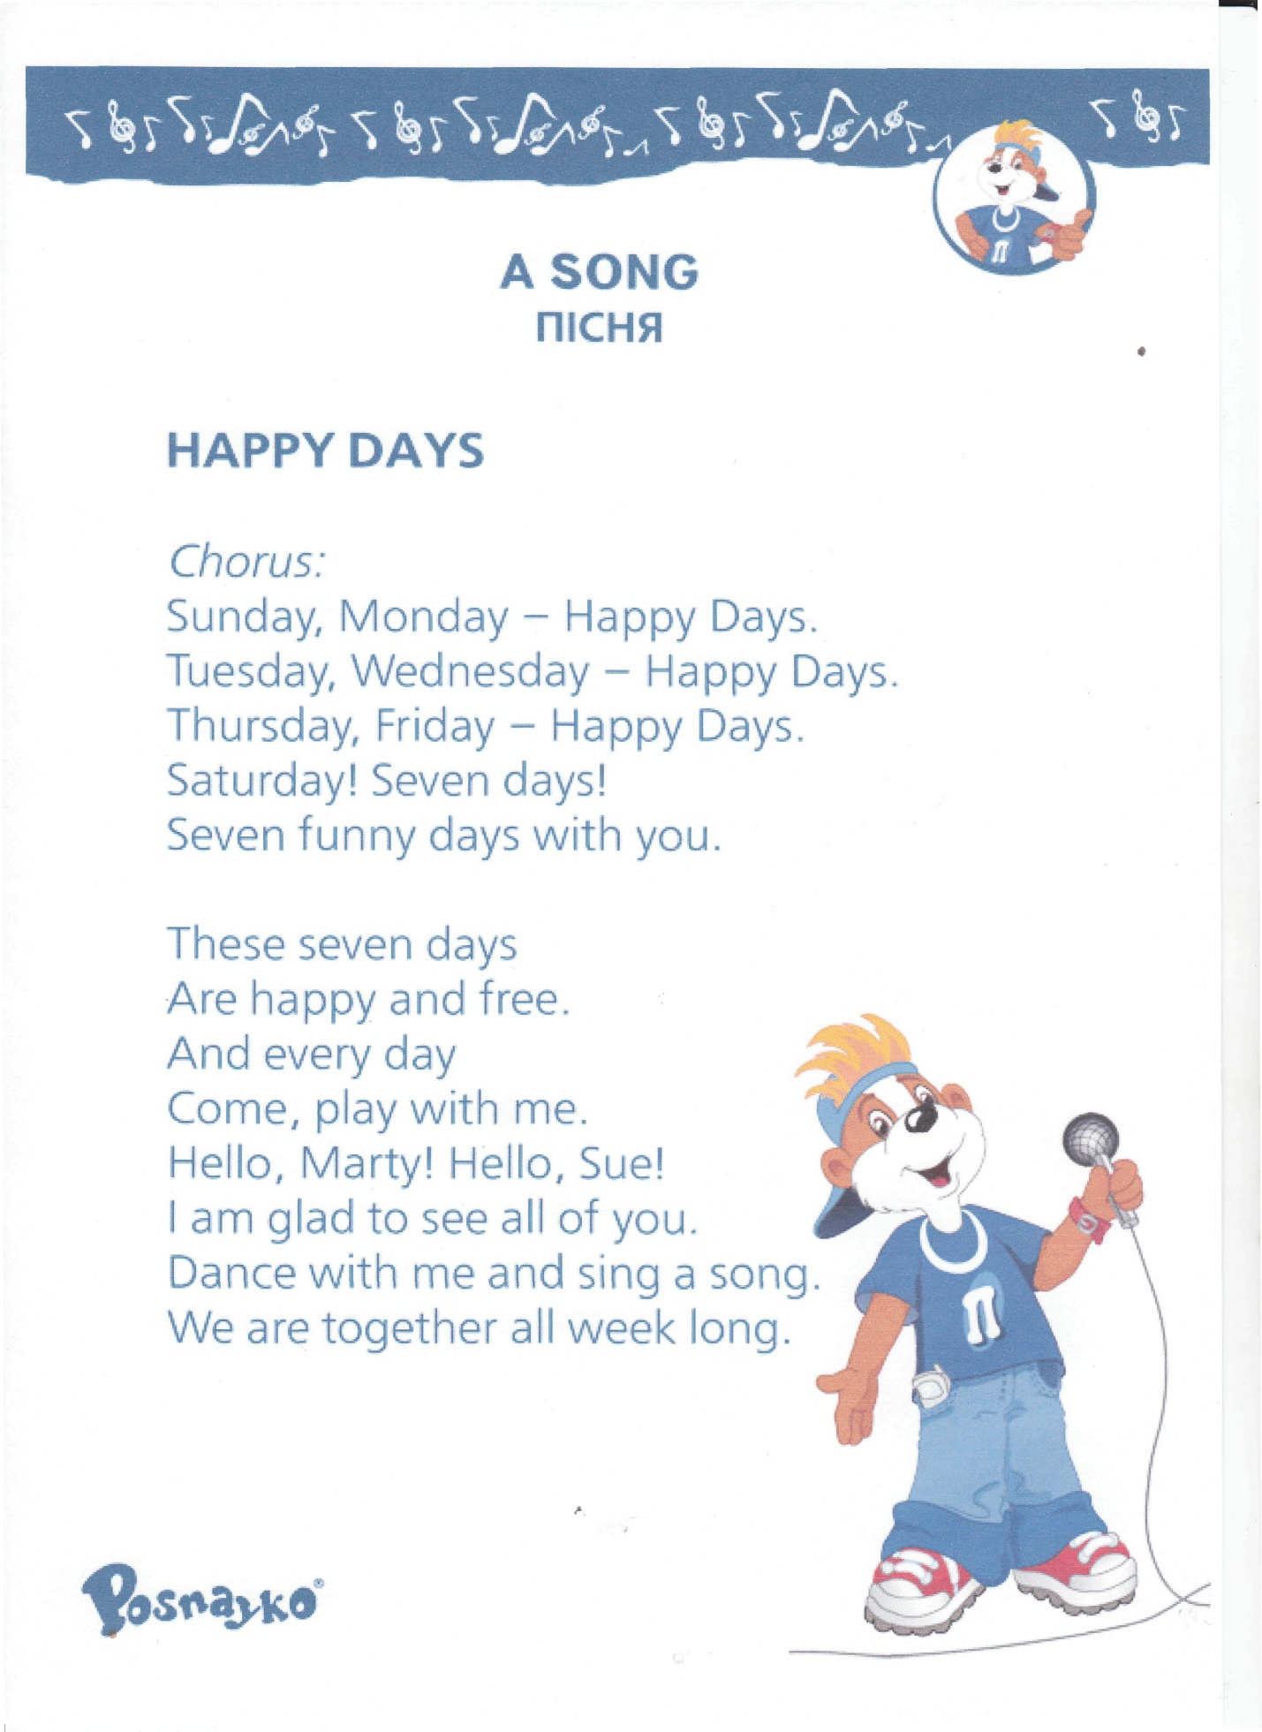

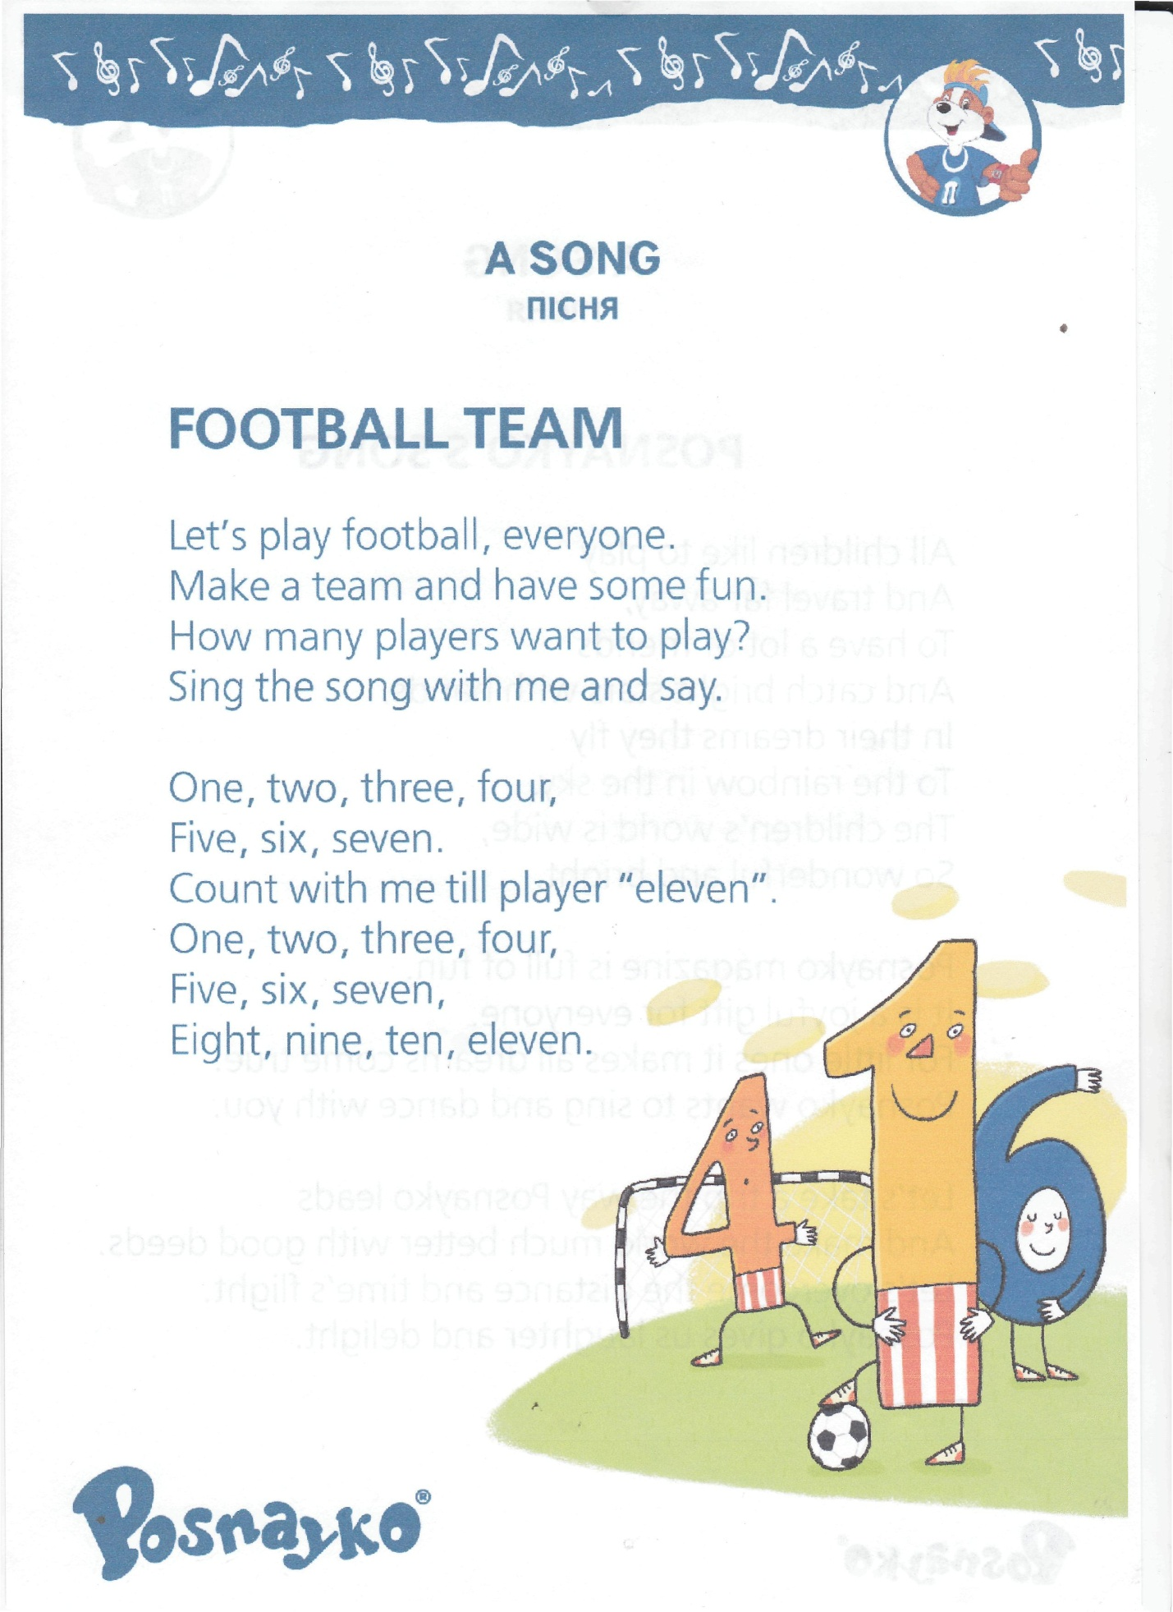

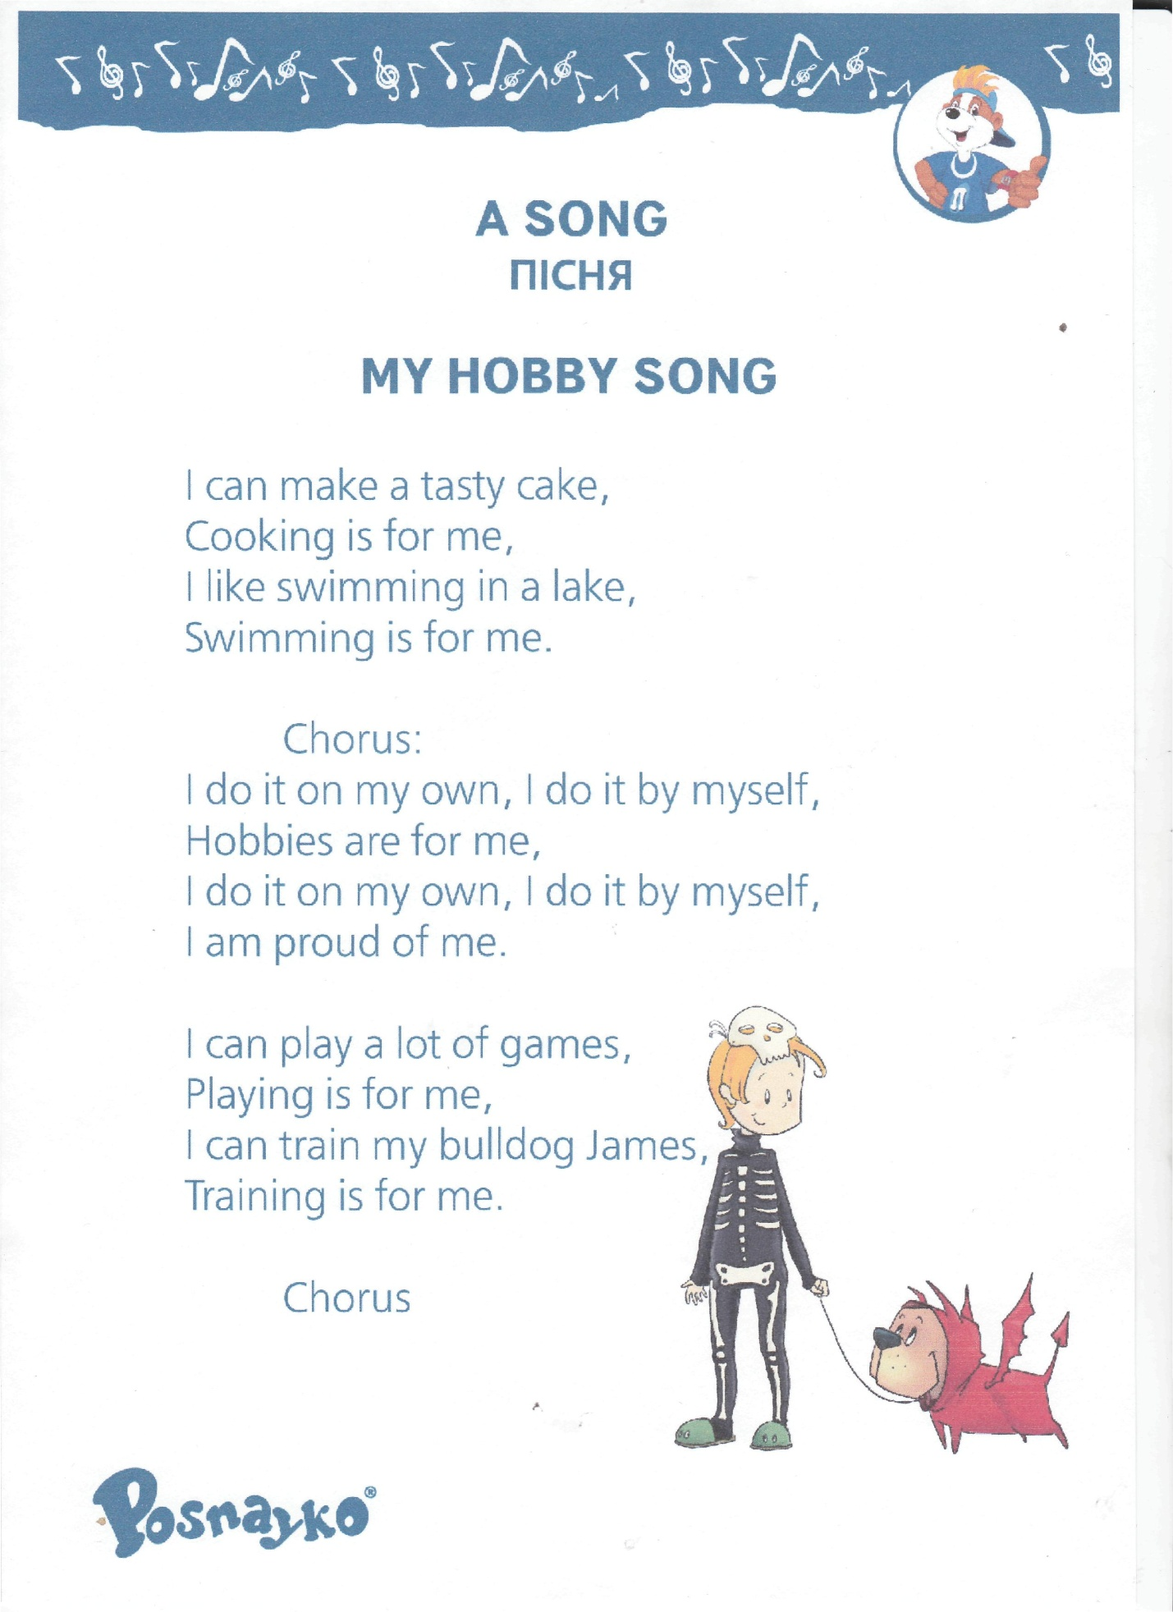

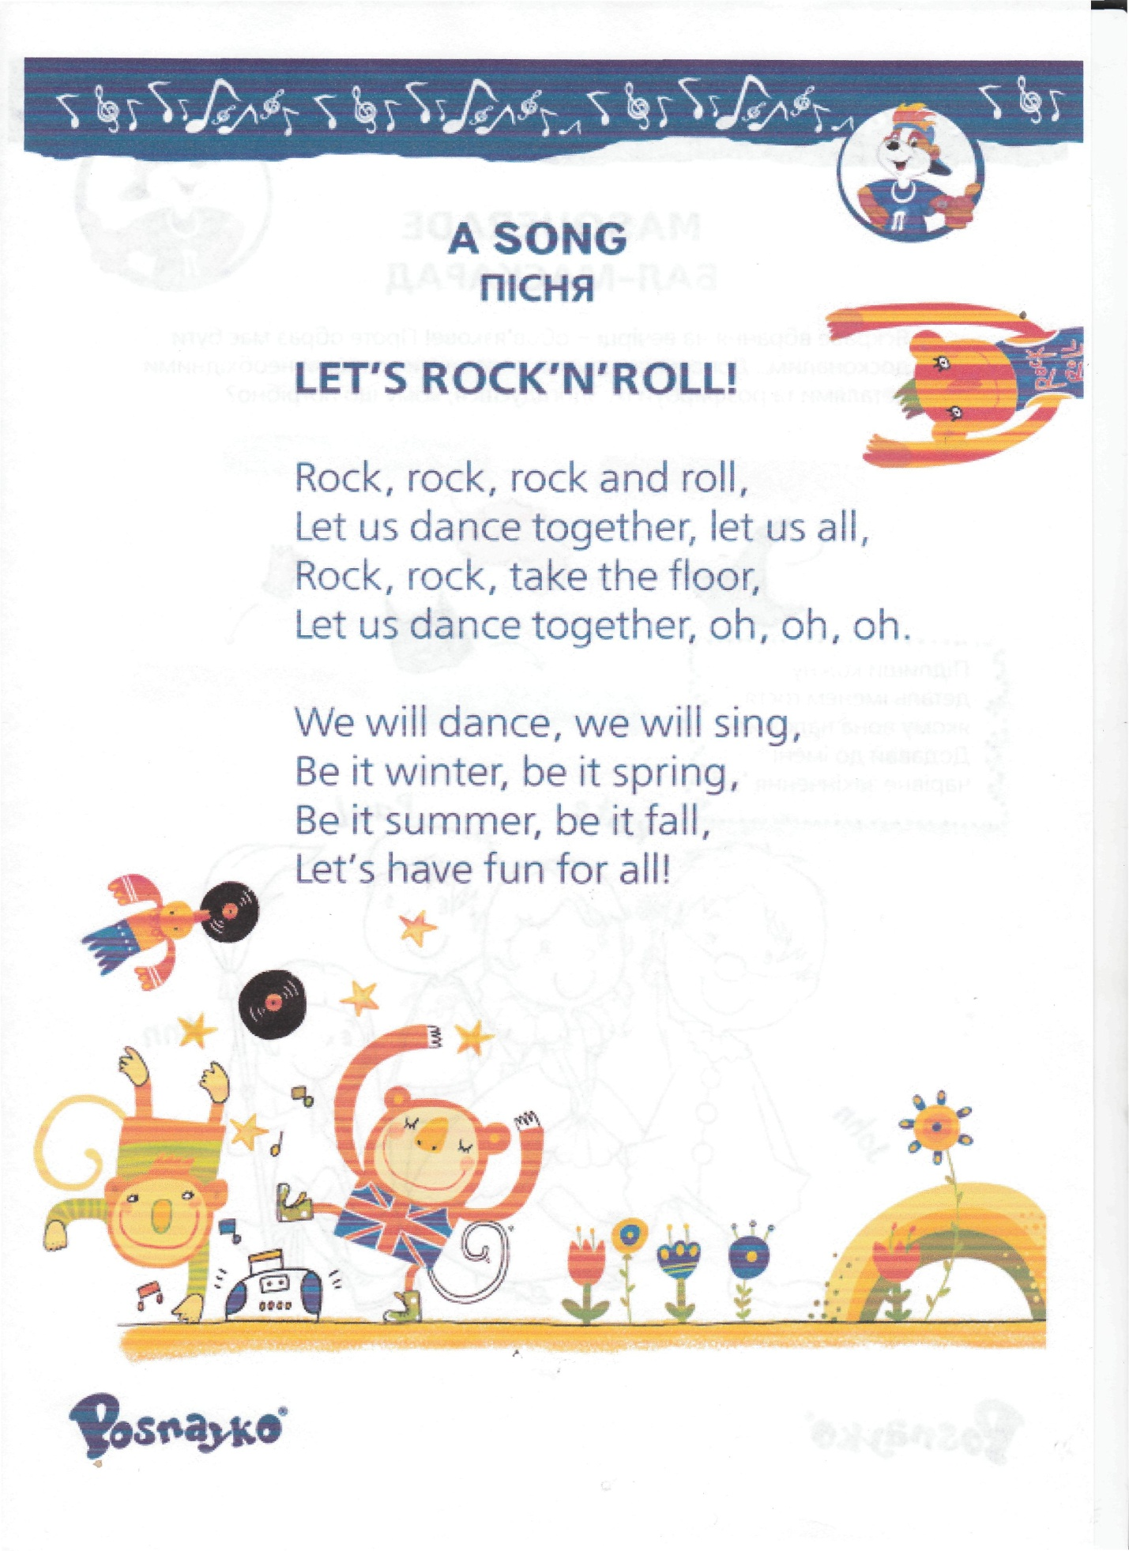

У розробці використані традиційні англійські ігри. Дана розробка може бути використана як:
- підсумовуючий звітний концерт про роботу під час щорічного предметного тижня;
- камерна акція як спосіб занурення учнів у англомовну атмосферу.
Дана розробка не є апробованою, захід буде проведено п’ятнадцятого квітня під час предметного тижня, чим і пояснюється відсутність відео звіту.
.

